Bare-metal programming for RISC-V
A hands-on guide
RISC-V India Developers Forum

Contents

1. Introduction 3
2. Environment Setup 4
Linux 4
Add username to sudoers list (When working with Ubuntu in Virtual Box) 4
QEMU 4
Some Useful RISC-V QEMU commands 5
GCC cross-compiler toolchain 5
Build system essentials 5
3. Some Useful Links 6
4. The First Boot 7

Introduction

The subject of this ebook is bare-metal programming in C for an RISC-V system.
Target Audience
This ebook is aimed at people who have an interest in low-level programming, and in seeing how to
build a system from the ground up. Topics covered include system startup, driver development and
low-level memory management. For the most part, the chapters cover things from a practical
perspective, by building something, although background theory is provided.

The reader should be familiar with C programming. This is not a C tutorial, and even though there
are occasional notes on the language, the ebook is probably diicult to follow without having
programmed in C. Some minimal exposure to an assembly language and understanding of
computer architecture are very useful, though the assembly code presented is explained line by
line as it’s introduced.

It’s also helpful to be familiar with Linux on a basic level. You should be able to navigate directories,
run shell scripts and do basic troubleshooting if something doesn’t work - fortunately, even for an
inexperienced Linux user, a simple online search is oen enough to solve a problem. The ebook
assumes all development is done on Linux, although it should be possible to do it on OS X and even
on Windows with some creativity.

Experienced embedded developers are unlikely to find much value in this text.

Environment Setup

In this chapter, we will cover the basic environment setup to get started with RISC-v bare-metal programming using an emulator. Some familiarity with using Linux is assumed. You don’t need to be a Linux expert, but you should be able to use the command line and do some basic troubleshooting if the system doesn’t behave as expected.

Linux
The first prerequisite is getting a Linux system up and running. Hopefully you are already familiar with Linux and have some kind of Linux running. Otherwise you should install Linux, or set up a virtual machine running Linux.
If you are running Windows and want to run a virtual Linux, VirtualBox is recommended. As for Linux distributions, any modern distribution should be fine, although in some cases you might need to install software manually. We use Linux Ubuntu Edition.
Recommended Configuration for Linux VM:
- 100 GB Hard Disk (Select Pre-allocate Option when setting up VM)
- 4 MB RAM
- No Of Processors: 1

Add username to sudoers list (When working with Ubuntu in Virtual Box)
You need root permissions to install any package in Ubuntu. For the same your username should be in sudoers list. Follow the procedure here to add username in sudoers list

QEMU
To emulate a RISC-V machine, we will be using QEMU, a powerful emulation and virtualization tool that works with a variety of architectures. While the code we write should eventually be able to boot on a real RISC-v device, it is much easier to start with an emulator. Why?
- No additional hardware is needed.
- You don’t have to worry about soware flashing / download process.
- You have much better tools to inspect the state of the emulated hardware. When working with real hardware, you would need a few drivers to get meaningful information from the software or use other more difficult methods.
Since QEMU supports a wide range of systems, we’ll need to install the RISC-V version. On Ubuntu based systems, the qemu-system-riscv64 (for 64-bit RISC-V machine) and qemu-system-riscv32 (for 32- bit RISC-V machine) package will provide what you need. We will be using qemu-system-riscv64 for this manual. So let’s just go ahead and install it:
sudo apt-get install qemu-system-riscv32

Some Useful RISC-V QEMU commands
- qemu-system-riscv32 –machine help
Lists all RISC-V machines supported by QEMU

GCC cross-compiler toolchain
The next step is the installation of a cross-compiler toolchain. You cannot use the regular gcc
compiler to build code that will run on an RISC-V system, instead you’ll need a cross-compiler. What
is a crosscompiler exactly? It’s simply a compiler that runs on one platform but creates executables
foranother platform. In our case, we’re running Linux on the x86-64 platform, and we want
executables for RISC-V, so a cross compiler is the solution to that.

The GNU build tools, and by extension GCC, use the concept of a target triplet to describe a
platform. The triplet lists the platform’s architecture, vendor and operating system or binary
interface type. The vendor part of target triplets is generally irrelevant. You can look up your own
machine’s target triplet by running gcc -dumpmachine. I get x86_64-linux-gnu, yours will likely be
the same or similar

To compile for RISC-V, we need to select the correct cross-compiler toolchain. RISC-V GNU compiler
toolchain supports two build modes: a generic ELF/Newlib toolchain and a more sophisticated
Linux-ELF/glibc toolchain. As we are dealing with bare metal programming here, we will be using a
generic ELF/Newlib toolchain.

Follow steps here to build and install RISC-V tool chain for Linux. For building toolchain for
freestanding program, just execute “make” rather than “make linux”. By default toolchain is built
for 64bit Machine. See this link to know how to build toolchain for 32 bit machine

Build system essentials
Finally, we need the essential components of a build system. In the coming examples, we’ll be using
CMake. CMake is available in a package called cmake, so the installation is simple:
sudosnap install cmake –classic
cmake --version

Some Useful Links
Pages
Share a Folder on Host with Guest OS in VirtualBox
VirtualBox Guest Additions Common Problems and Solutions
Can't see shared folders in VirtualBox Ubuntu VM?
Virtualbox shared folder permissions

Video
Virtualbox Shared Folder NOT Working - Fixed

The First Boot

We’ll continue our introduction to bare-metal RISC-V by starting an emulated RISC-V machine in
QEMU, and using the cross-compiler toolchain to load the simplest possible code into it.

  - hello_world assembly program
.section .text
.global _start
.type _start, @function
.option arch, +zicsr

_start:
li x5,0x10000000 // x5 = @ XS16550 transmitter holding register
la x6,_hello // x6 = @ of null-terminated string to print
// check if nothing to print
lb x7,0(x6) // x7 = next byte to print from the string
beq x0,x7,_end // if the character is \0 then we are done...
// have something to print
_loop:
sb x7,0(x5) // ...else write it to the THR
addi x6,x6,1 // advance string pointer to the next character to print
lb x7,0(x6) // x7 = next byte to print from the string
bne x0,x7,_loop // if the character is NOT \0 then keep going
_end:
// disable ALL irqs
csrw mie,x0 // Spin while waiting for an interrupt that can never arrive.
// (Seize the hart.)
_intr_loop:
wfi // This will prevent qemu from using 100% of a host core!
j _intr_loop
.section .rodata // want in a data section so not end up in an exec only
// page!
_hello:
.asciz "Hello World!\n" // asciz strings have a null-character appended to
// it: 48 65 6c 6c 6f 20 57 6f 72 6c 64 21 0a 00
.end

  - 2 Step process to generate executable

    - Compile assembly file
riscv32-unknown-elf-gcc -ffreestanding -march=rv32i -mabi=ilp32 -O -c -o hello_world_asm.o hello_world_asm.S

- -ffreestanding: Assert that compilation targets a freestanding environment. A freestanding
environment is one in which the standard library may not exist, and program startup may
not necessarily be at main
- -march: Machine architecture being emulated
- -mabi: Application Binary Interface (ABI) being used. It dictates how CPU registers are used.
- -O: With -O, the compiler tries to reduce code size and execution time, without performing any optimizations that take a great deal of compilation time.
- -c: Only assemble or compile but not link
- -o: Name of obj file to be generated

    - Link Assembly file
riscv32-unknown-elf-gcc -ffreestanding -march=rv32i -mabi=ilp32 -O -nostdlib -Wl,-Ttext=0x1000 -Wl,--no-relax -Wl,-Tdata=0x800 -o hello_world hello_world_asm.o

Options already described in section 4.2.1 are not repeated here
- -nostdlib: Do not use the standard system startup files or libraries when linking. No startup files and only the libraries you specify are passed to the linker
- -Wl,option: Pass option as an option to the linker. If option contains commas, it is split into multiple options at the commas
- -Ttext: One of –Wl options, Address at which .text section is loaded
- -Tdata: One of –Wl options, Address at which .data section is loaded
- --no-relax: One of –Wl options, An instruction to assembler not to do any optimizations in assembly code.

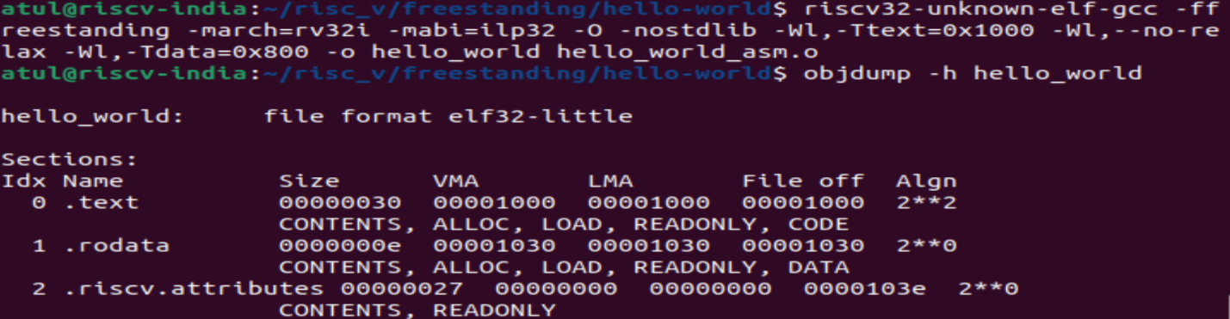
  - Run hello_world executable on QEMU

Let us run QEMU, with hello_world executable generated as mentioned in section 4.2.2, for the very
first time, with the following command:
qemu-system-riscv32 -machine virt -m 128M -bios none -device loader,file=./hello_world -nographic -s

For documentation of the QEMU command line, you can check man qemu-doc and online, but
let’s go through the command we used and break it down into parts.

- -machine virt. The -machine switch selects the specific machine to be emulated. The “virt” is a RISC-V platform intended for prototyping and testing.
- -m 128M. This simply sets the RAM of the emulated machine to 128 megabytes.
- -bios none. The virt machine can start using the standard -kernel functionality for loading a Linux kernel, a VxWorks kernel, an S-mode U-Boot bootloader with the default OpenSBI firmware image as the -bios. With –bios none, this option is disabled.
- -device loader: The ‘loader’ device allows the user to load multiple images or values into QEMU at startup
- File=./hello_world: Path of image to be run on QEMU
- -nographic: Run QEMU as a command-line application, outputting everything to a terminal console. The serial port is also redirected to the terminal
- -s: Shorthand for -gdb tcp::1234, i.e. open a gdbserver on TCP port 1234

Output

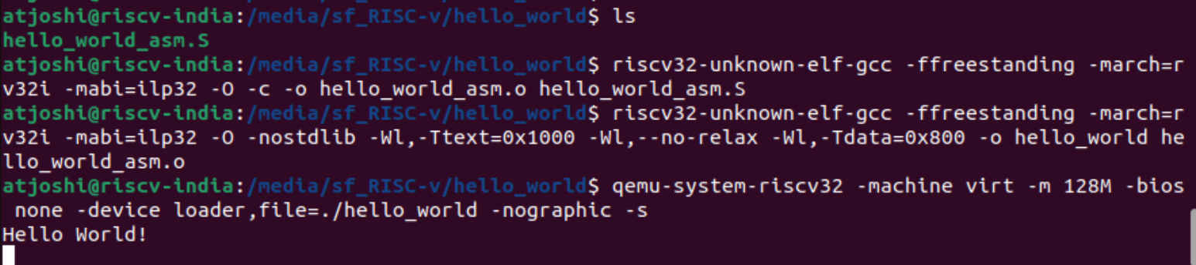

QEMU stalls after printing “Hello World!”. To come out of QEMU press “ctrl + A” followed by “X”

What we did wrong

Our code worked, but even in this small example we didn’t really do things the right way.

Memory mappings
One issue is that we didn’t explicitly specify any start symbol that would show where our
program should begin executing. It works because when the CPU starts up, it begins executing
from address 0x1000, and we have placed a valid instruction at that address. But it could easily
go wrong. Consider this variation of hello_world_asm.S, where we write an invalid instruction
at the beginning. We wrote riscv there which is an invalid instruction

_start:
riscv
li x5,0x10000000
la x6,_hello

The text “riscv” would end up at address 0x1000, and that’s not a valid instruction to
begin the program with. Moreover, even starting at address 0x1000 isn’t really correct. On a
real system, the interrupt vector table should be located at address 0x1000 (or any other start
address), and the general boot process should first have the bootloader starting, and aer that
switch execution to your code, which is loaded somewhere else in memory.

Creating the vector table

Having our code start at address 0x0 isn’t acceptable as explained before, as that is the
address where the interrupt vector table is expected. We should also not rely on things just
working out, with help from QEMU or without, and should explicitly specify the entry point for
our program. Finally, we should separate code and data, placing them in separate sections.
Let’s start by improving our c a bit, let us name new file as hello_world_with_vector_table.S:
.option arch, +zicsr
.section .vector_table, "x"
.global _Reset
_Reset:
li x5,0
beq x0,x5,_start

.section .text
.global _start
.type _start, @function
_start:
li x5,0x10000000 // x5 = @ XS16550 transmitter holding register
la x6,_hello // x6 = @ of null-terminated string to print
// check if nothing to print
lb x7,0(x6) // x7 = next byte to print from the string
beq x0,x7,_end // if the character is \0 then we are done...
// have something to print
_loop:
sb x7,0(x5) // ...else write it to the THR
addi x6,x6,1 // advance string pointer to the next character to print
lb x7,0(x6) // x7 = next byte to print from the string
bne x0,x7,_loop // if the character is NOT \0 then keep going
_end:
// disable ALL irqs
csrw mie,x0 // Spin while waiting for an interrupt that can never arrive.
// (Seize the hart.)
_intr_loop:
wfi // This will prevent qemu from using 100% of a host core!
j _intr_loop
.section .rodata // want in a data section so not end up in an exec only
// page!
_hello:
.asciz "Hello World!\n" // asciz strings have a null-character appended to
// it: 48 65 6c 6c 6f 20 57 6f 72 6c 64 21 0a 00
.end

Here are the things we’re doing dierently this time:
- We’re creating the vector table at address 0x1000, putting it in a separate section called .vector_table, and declaring the global symbol _Reset to point to its beginning. We leave most items in the vector table undefined, except for the reset vector, where we place the instructions to reset handler, which start at _start symbol.
- We moved our executable code to the .text section, which is the standard section for code. The _start label points to the code so that the reset interrupt vector will jump to it.

Creating the Linker Script

Linker scripts are a key component in building embedded soware. They provide the linker with information on how to place the various sections in memory, among other things. Let’s create a linker script for our simple program, call it linkscript.ld.
ENTRY(_Reset)
SECTIONS
{
. = 0x1000;
.text : { hello_world_with_vector_table.o (.vector_table) *(.text) }
. = ALIGN(8);
}

This script tells the linker that the program’s entry point is at the global symbol _Reset, which we export from hello_world_with_vector_table.S. Then the script goes on to list the section layout. Starting at address 0x1000, we create the .text section for code, consisting first of the .vector_table section from hello_world_with_vector_table.o, and then any and all other .text sections. We align the code to an 8-byte boundary as well.

What is linker?

Indeed, what’s a linker and why are we using one? As developers, we oen say “compilation” when referring to the process by which source code turns into an executable. More accurately though, compilation is just one step, normally followed by linking, and it’s this compile-and-link process that oen gets simply called compilation. The confusion isn’t helped by the fact that compiling and linking are usually invoked with the same command in most tools. Whether you’re using an IDE or using GCC from the command line, compilation and linking will usually occur together.

The compiler takes source code and produces object files as the output, these files usually have the .o extension. A linker takes one or more object files, possibly adds external libraries, and links it all into an executable. In any non-trivial program, each object file is likely to refer to functions that are contained in other object files, and resolving those dependencies is part of the linker’s job. So linkers themselves are nothing specific to embedded programming, but due to the low abstraction level available when programming for bare metal, it’s common to require more control over the linker’s actions.

Linker scripts like the one above, in the broadest terms, tell the linker how to do its job. For now we’re just giving it simple instructions, but later we’ll write a more sophisticated linker script.

Compiling hello_world_with_vector_table.S:
riscv32-unknown-elf-gcc -ffreestanding -march=rv32i -mabi=ilp32 -O -c -o hello_world_with_vector_table.o hello_world_with_vector_table.S

Linking hello_world_with_vector_table.S:
riscv32-unknown-elf-gcc -ffreestanding -march=rv32i -mabi=ilp32 -O -nostdlib -Wl,--no-relax -T linkscript.ld -o hello_world_with_vector_table hello_world_with_vector_table.o

Note the addition of -T linkscript.ld to the linker command, specifying to use our newly created linker script. We could use objdump to verify that our linkscript changed things.

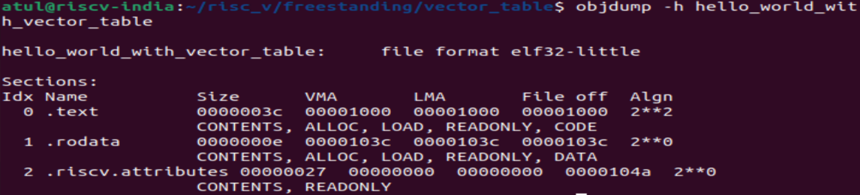

Execute hello_world_with_vector_table.S on QEMU:
qemu-system-riscv32 -machine virt -m 128M -bios none -device loader,file=./hello_world_with_vector_table -nographic -s

Output:

Adding a bootloader

Introduction
The bootloader is a critical piece of soware that is necessary to get the hardware into a usable
state, and load other more useful programs, such as an operating system. On PCs and other fully-
featured devices, common bootloaders include GNU GRUB (which is most likely used to boot your
Linux system), bootmgr (for modern versions of MS Windows) and others. Developing bootloaders
is a separate and complicated subject. Bootloaders are generally full of esoteric, highly architecture-
specific code, and in my opinion learning about bootloaders if fun, but the knowledge is also
somewhat less transferable to other areas of development.

Writing your own bootloader is certainly something that could be attempted, but in this series of
posts we will continue by doing something that is usually done in embedded development, namely
using Das U-Boot.

Das U-Boot, usually referred to just as U-Boot, is a very popular bootloader for embedded devices.
It supports a number of architectures, including RISC-V, and has pre-made configurations for a very
large number of devices. Our goal in this article will be to build U-Boot, and combine it with our
previously built soware. This will not, strictly speaking, change anything significant while we are
running on an emulated target in QEMU, but we would need a bootloader in order to run on real
hardware.

We will, in this article, change our boot sequence so that U-Boot starts, and then finds our program
on a simulated SD card, and subsequently boots it. I will only provide basic explanations for some of
the steps, because we’ll mostly be dealing with QEMU and Linux specifics here, not really related to
RISC-V programming.

Preparing U-Boot

First, you should download U-Boot. You could clone the project’s source tree. I used v2023.04
branch to build U-Boot. While building you may get some errors owing to missing packages. Please
install them as needed.

Run following command inside u-boot folder
CROSS_COMPILE=riscv32-unknown-linux-gnu- make -j20

This will compile U-Boot for machine mode. To build supervisor mode binaries, use the
configurations qemu-riscv32_smode_defconfig and qemu-riscv64_smode_defconfig instead. Note
that U-Boot running in supervisor mode requires a supervisor binary interface (SBI), such as RISC-V
OpenSBI.
Starting U-Boot

Following is the simpleast QEMU command to start U-boot
qemu-system-riscv32 -machine virt -m 128M -nographic -bios ../../u-boot/u-boot.bin

Please note argument passed along with “-bios” option. This is the path of “u-boot.bin” which was
created as part of u-boot build process described in previous section.

